1. Why mainstream?
Tips on mainstreaming
The relationship between climate change, environment and sector development is complex (see Figure 1). Environmental degradation can affect the availability of ecosystem services critical to agriculture through pollution, land degradation and over-harvesting of natural resources. At the same time, climate change exacerbates trends in environmental degradation with more intense rainfall, longer and more frequent droughts, shifts in seasons, increased temperatures. Reducing GHG emissions is therefore important in mitigating the effects of climate change. Mainstreaming helps to identify, avoid and mitigate any harmful impacts of development on the environment and climate.
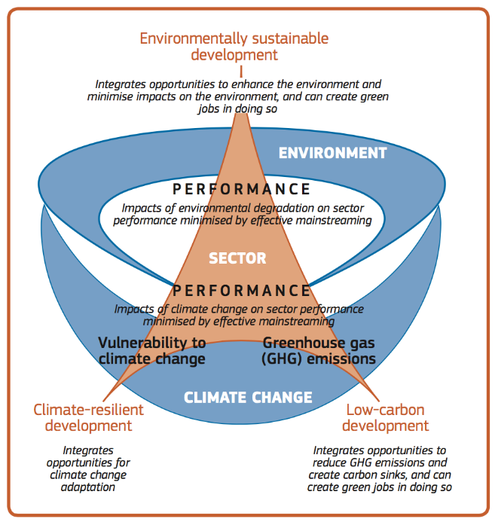
Figure 1 Relationship between climate change, environment and sector development and benefits of mainstreaming
Hence, addressing environmental and climate change considerations as an integrated part of development is crucial to achieving environmental sustainable development and tackling climate change. Failing to address environment and climate related risks and constraints could jeopardise the achievement of sector and national development objectives.
Resilience to climate risks will depend on the extent to which development plans incorporate flexible adaptive and mitigation measures. National policies, strategies and programmes, designed on the basis of stable climatic conditions need to be adapted to the risks associated with extreme weather conditions, disruption in seasonal trends and climate variability. This could mean introducing measures to develop crops that are drought resistant or developing irrigation schemes that take future water availability into account.
Mainstreaming can also exploit opportunities for socio-economic development by shifting to low carbon development pathways (e.g. solar powered irrigation and agro-processing), by leveraging carbon finance, mitigating extreme weather events and creating new income generating activities and green jobs.
The mainstreaming process analyses and addresses risks and identifies and exploits opportunities in order to:
- minimise adverse environmental impacts of policies, plans and programmes;
- ensure that development strategies, plans and investments are resilient to climatic shocks and stresses;
- exploit opportunities for economic growth to take place through low carbon development pathways and enhance the environment; and
- ensure that development planning continues to contribute to the improvement of livelihoods and inclusive rural growth.
Successful mainstreaming will therefore result in the systematic integration of environment and climate concerns in policies, plans and programmes in order to balance environmental, economic and social objectives and contribute to environmentally sustainable, climate resilient and low carbon development pathways.

2. Approaches to mainstreaming
There is no blueprint approach to mainstreaming. This approach adopted has been developed with the country and sector context in mind. It aims to exploit opportunities for integrating environment and climate concerns into sector policies, plans and projects. These can be at both the institutional and operational levels and includes top-down and bottom-up processes. It is important to note that mainstreaming is an iterative process and does not necessarily follow a sequential process so flexibility and adaptive management are key requirements. At the same time, any particular mainstreaming project or initiative may not seek to include all the stages below but may choose to focus on a few of the critical areas.
The key stages of mainstreaming broadly follow and build on the guidance issued by REMA on mainstreaming climate change. These include:
- Raise awareness and engage stakeholders
- Develop sector-specific evidence
- Integrate climate and environment concerns into policy and strategic frameworks for the sector
- Identify and appraise mainstreaming entry points and options for interventions that address climate and environment concerns
- Mobilise funding for interventions that address climate and environment concerns
- Strengthen human and institutional capacities and inter-sectoral coordination
- Assess and evaluate mainstreaming actions
- Sustain the communication and knowledge building efforts

Raise awareness and engage stakeholders
Awareness raising is the starting point for securing buy in from the key stakeholders for mainstreaming climate and environment concerns in agricultural development. This also involves active engagement with government and key stakeholders to put environment and climate change on the agenda and to include the relevant stakeholders, including civil society in order to contribute to sector-led mainstreaming and build ownership. This will entail using the most appropriate platforms and communication channels for advancing environment and climate change mainstreaming and understanding current priorities and plans for the respective sector. It will also involve close coordination with the lead agencies on environmental and climate change issues i.e. REMA and projects such as the PEI and the DEMP. Building knowledge and understanding across all the stakeholder groups in the sector will require ongoing and effective communication.

Develop sector-specific evidence
Policy, planning and programming dialogue around the need for mainstreaming is most effective when backed up with evidence and information, such as data, studies and examples of previous experience. This could include economic analysis of Business As Usual (BAU) and alternative climate sensitive and environmentally sustainable interventions that consider cross cutting issues to make the case for mainstreaming. Generating evidence can inform future policy choices, and encourage policy options that better address environmental and climate change issues.

Integrate climate and environment concerns into policy and strategic frameworks for the sector
Identify emerging opportunities to engage in policy dialogue and mainstream cross cutting issues more effectively in the policy and strategic planning frameworks. Integrating climate and environment concerns into the existing and new policy and strategic framework can foster the integration of mainstreaming activities into plans and budgets.
Existing monitoring systems (e.g. indicators, data collection and analysis) can also be modified to include climate change and environment indicators at different levels to capture key environmental and climate change concerns. Regular performance assessments e.g. Joint Sector Reviews and Imihigo could include review of progress on mainstreaming climate and environment using appropriate indicators.

Identify entry points
Entry points are key points in policy and planning cycles where mainstreaming can take place. The aim will be to identify and exploit opportunities to enhance and re-orient environmental and climate-related performance of both existing or planned activities. There are a number of potential entry points for mainstreaming:
- Policy and strategy development – this will involve engaging effectively in the policy dialogue process and assessing whether the policy or strategy adequately integrates environmental and climate-related considerations and developing performance indicators to track progress;
- Project design – this will involve using the problem and stakeholder analysis and the EIA if required to identify environmental and climate change–related issues and design appropriate interventions and risk mitigation measures to avoid adverse environmental impacts (referring to the most recent National Communication on Climate Change, the GGCRS, the NAPA, the NAMA and the climate vulnerability index);
- Routine M&E of projects – this will entail including relevant environmental and climate change indicators in the monitoring system, plans and reports, as well as ensuring that environmental and climate change results are regularly discussed by relevant stakeholders and by the steering committee, additionally, an ad hoc review of programme/project environmental and climate change performance can be undertaken to identify further opportunities to minimise environmental and carbon footprints;
- Mid-term reviews of implementation of strategic plans and projects to evaluate whether the strategy adequately integrates environmental and climate-related considerations and to guide interventions during the remaining period of implementation - this will involve reviewing and revising where needed the evaluation criteria and questions to better capture environmental and climate concerns;
- Final evaluations of strategic plans and projects to draw lessons for future plans and programmes;
- Procurement processes – this will involve including environmental criteria (e.g. energy/water efficiency, the absence of hazardous substances, low emissions etc.); and
- Annual and medium-term expenditure and budgetary frameworks – these can be used to streamline the integration process.

Identify and appraise mainstreaming options
With the aim of achieving the integration of climate resilience into development planning a variety of approaches can be used. A sector-wide programmatic approach would mean reviewing sector budgets, development and investment plans as well as institutional arrangements. Alternatively, an opportunity to mainstream at project or district level may arise from a new investment or a new funding opportunity. Various interventions can be used with both existing and new initiatives.
Existing programmes, plans and policies. A climate/environment-proofing approach can be used to modify development interventions that have been planned without due consideration of the climate and environment context by increasing capacity to cope with – and recover from – the impacts of existing climate variability as well as introducing more stringent social and environmental safeguards. In this case, climate resilience and strengthened environmental safeguards are integrated post-programme design to minimise the impact of the project on the environment and to minimise impacts of climate change on the intervention.
New programmes, plans and policies. Here there is an opportunity to ensure that climate and environment concerns are considered from the very early stages of the design. It can entail the piloting of climate resilient, low carbon or environmentally sustainable approaches with a view to scaling up successful approaches. This means that approaches can be tested before investing significant resources are governments in integrating them into regular development planning. Alternatively, measures can be used to make development planning processes resilient to climate change, environmentally sustainable and contribute to low carbon goals so they can deliver development outcomes in the EDPRS II and the GGCRS. This approach enables the sector to mainstream from a development planning systems approach.
Once the mainstreaming intervention has been analysed and decided upon, the next step is to conduct an institutional mapping exercise to provide an overview of the institutions and other stakeholders involved in the area of focus e.g. tea, livestock, irrigation etc. This will provide an overview of the coverage, scale, and coordination of existing interventions, provide an assessment of how climate and environment issues are currently addressed and how planning and implementation is coordinated between departments and linkages to other government bodies. It highlights all the relevant stakeholders including government, donors, NGOs, and the private sector.

Mobilise funding for interventions that address climate and environment concerns
The existing allocation of funds for mainstreaming cross cutting issues may be insufficient. Resource mobilisation can therefore play a key role in integrating climate and environment considerations into development planning by funding specific actions that promote and mainstream environmentally sustainable agriculture and climate resilient, low carbon development of a sector.
There are a number of international climate funds that are supporting the the strategic integration of climate resilience into development planning. These include the PPCR and FIP which bring multiple projects and planning processes under a single programme framework, achieving strategic integration across climate change and development policy objectives. These can then be funded by a variety of financial instruments thereby mainstreaming climate resilience into short-, medium- and long-term budgetary instruments. The effective use of climate funds therefore enables the resourcing of climate change and environmental interventions.

Strengthen human and institutional capacities and inter-sectoral coordination
Capacity building of target stakeholder groups is an important activity in bringing about improved mainstreaming in agricultural development. Experiences and lessons learned from pilot interventions can be shared through a series of thematic workshops/training events with key stakeholders to exchange and build knowledge and capacity around climate and environmental issues. Knowledge products such as guidelines and policy briefs based on the analyses can highlight environment and climate issues and their relationships to development outcomes, lessons learned and examples of good practice that contribute to improving environmental sustainability, climate resilience and low carbon development.
Collaboration with key sectors including natural resources (MINIRENA) and infrastructure (MININFRA) is important and improved cross working is needed to improve coordination and achieve economies of scale in tackling cross cutting issues.

Assess and evaluate mainstreaming actions
Assessing and evaluating mainstreaming actions is necessary to understand if the actions being undertaken are making a difference in terms of strengthening climate resilience, promoting the use of low carbon technologies and approaches and safeguarding the environment. It requires the use of appropriate indicators that can:
- help identify if key environmental and climate change concerns, risks and opportunities have been addressed,
- track the efficiency and effectiveness of mainstreaming measures, and
- allow the early identification of unexpected adverse environmental and climate change impacts that may arise, thereby enabling the intervention(s) to be revised accordingly.
The participation of relevant stakeholders including senior managers during monitoring is helpful so that the results can be discussed and follow-up actions can be agreed upon and carried out.

Mainstreaming support and oversight
To ensure a coordinated and informed approach to the integration of environment and climate concerns in planning and project cycles, additional TA may be needed to provide technical assistance and oversight in implementing, monitoring and evaluating the mainstreaming process. Key responsibilities will include:
- coordinating and monitoring the incorporation of the mainstreaming approach in selected policies, plans and projects;
- building awareness;
- providing technical assistance to strengthen mainstreaming activities and mobilise resources for mainstreaming;
- supporting M&E functions in the identification/revision of; and
- planning and follow-up of mainstreaming activities.

Institutionalising climate and environmental mainstreaming
Institutional arrangements are important in directing the mainstreaming agenda as they these determine the extent to which key agencies can support the coordinated integration of climate and environmental concerns into development planning at local and sectoral levels. As mainstreaming requires change albeit iterative, the support of senior managers and key stakeholders for the implementation of mainstreaming is critical.
In Rwanda, the development of the climate change and environment agenda has very much been country-driven and based on existing development priorities and capacities. It is important therefore that national stakeholders continue to determine how climate and environment issues are relevant to sector plans and decide on what actions to take based on their own capacities and priorities. The approach should therefore be pragmatic and context- specific targeting change strategically and operating with national resources to ensure sustainability.
Strengthening the buy in and political will can be challenging but it is often critical in driving the mainstreaming agenda. There is strong political will at the national level for mainstreaming as reflected in the EDPRS II and GGCRS. At the sector level, however, challenges exist in balancing urgent development needs with longer-term environmental and climate goals. In particular, there are currently limited incentives for district authorities to engage with mainstreaming initiatives. Mainstreaming climate and environment concerns needs to be a key policy objective and senior managers need to recognise their role in translating mainstreaming objectives into action. In the sector planning context, key drivers of political will are politicians, technocrats and development partners (and to a lesser extent the private sector and civil society).

From EU Guidance Note: Towards Sustainable Development: Mainstreaming Environment and Climate Change into Development

